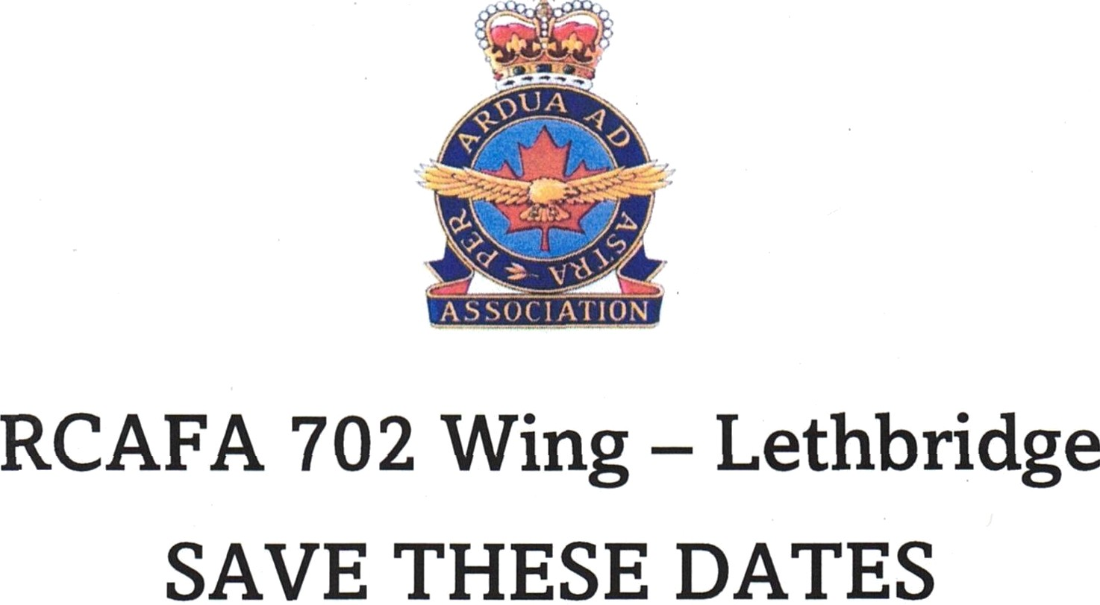

We invite you to join us in the following events:

*Lobsterfest - May 31st. $90 this year.*

*Charter Night – September 20.*

*Corn Roast at the end of August.*

*May 10 – Mother’s Day Potluck.*

Mark the above dates on your calendars as it will be a great get together. You should also be receiving a call from the phoning committee prior to each event. Hope to see you there!!