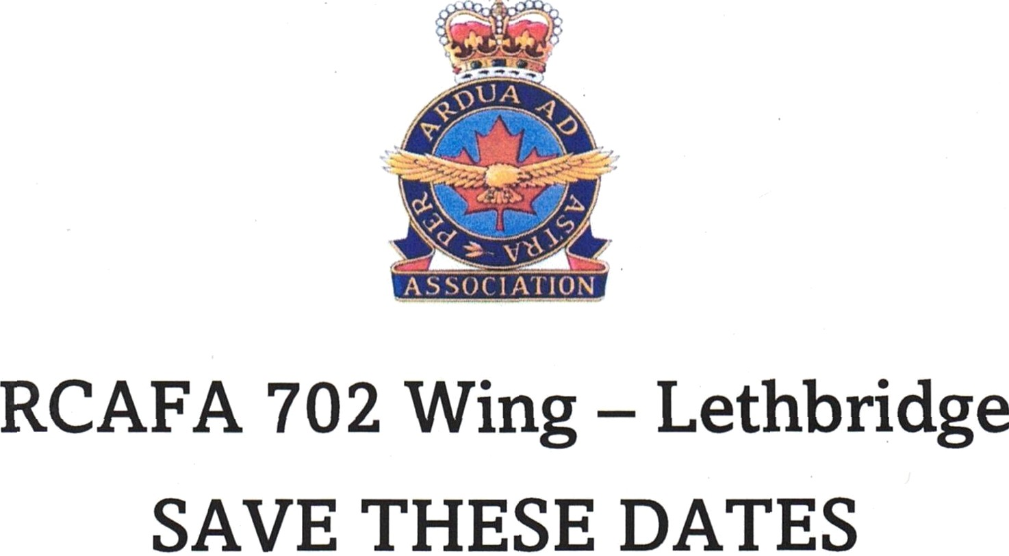

We invite you to join us for the following events in 2024:

February 10 - Valentine’s Social.
March 16 – St Patricks day brunch.
April 20 - Charter Event Our charter came about on April 1, 1949. Further info as to how and what this event will look like will be forthcoming.
May 25 – Lobsterfest.
June 15 – Pot luck.
August. 24 – Welcome back corn roast.
September – AGM followed by a pot luck.
October 26 – Halloween pot luck.
November 11 – Remembrance day, open house (tentative on if we get an aircraft)
November 30 – Hall xmas decorating with pot luck.
December 7 – Wing xmas party.

We hope you will mark the above dates on your calendars as it will be great to get together again. You should also be receiving a call from the phoning committee prior to each event. Hope to see you there!!

